Chapter 3 Study Guide: Spatial Vision
Key terms:
- Aliasing- misperception of a grating due to undersampling, or misperceiving the cycles to be longer than they actually are. Ex. If an entire sample falls on just one cone
- Amplitude- the distance between the top of the crest or to the bottom of a trough of a wave.
- acuity- the smallest spatial detail that can be resolved
- contrast- the difference in luminance between an object and the background or between lighter and darker parts of the same object
- spatial frequency- the number of cycles of a grating per unit of visual angle
- visual angle- the angle subtended by an object at the retina.
- topographical mapping- the orderly mapping of the world in the LGN and the visual cortex.
- orientation tuning- the tendency of neurons in striate cortex to respond optimally to certain orientations and less to others.
- phase- the relative position of a grating
- cortical magnification –the amount of cortical area devoted to a specific region in the visual field-
- simple cell-a cortical neuron with clearly defined excitatory and inhibitory regions (responds to oriented edges and gratings)
- complex cell- a neuron whose receptor field characteristics cannot easily be predicted by mapping with spots of light. (spatial invariance) stimuli of certain orientation, moving in a specific direction
  - hypercomplex cells- prefer orientation AND end stopping (a decrease in firing strength with increasingly larger stimuli) orientation, moving in a direction, of a specific length
- adaptation- a reduction in response caused by prior or continuing stimulation.

What are receptive fields and size to perceive texture
Spatial frequency- the number of times a pattern, such as a grating, repeats in a given unit of space. In order to perceive texture we rely on our contrast sensitivity function. This is a function describing how the sensitivity to contrast depends on the spatial frequency (size) of the stimulus. The receptive field must be smaller than ½ the period of the sine wave to perceive the texture.
Snellen’s 1862 method for designating
A Snellen chart is an eye chart that is used in order to measure visual acuity. There are essentially 11 lines of text. The first row is one big letter and the subsequent rows have more letters of decreasing size. Basically your standard eye chart in a doctors office. So essentially he developed the 20/20, 20/40 etc. if you have 20/40 visual, this means that if you would need to stand 20 feet away from a sign that someone with 20/20 vision could read from 40 feet away in order to read it.
Hubel and Wiesel’s experiment as seen in the video on the slides
Hubel and wiesel recorded the sound of neurons in the visual cortex of a cat when they moved a bright line across its retina. They discovered that the neurons would only fire when the line was in a specific place on the retina, the orientation changed the firing, and sometimes neurons fired in response to movement in a specific direction. They discovered that there is a topographical map of the world in the LGN as well as simple, complex, and hypercomplex cells that fire in response to different types of stimuli.

What do retinal ganglion cells respond to?
On center, off surround- excited by central light and inhibited by peripheral light.
Off center, on surround- opposite

Know the entire pathway of a visual signal (starting at the retina) and where the signal converges.

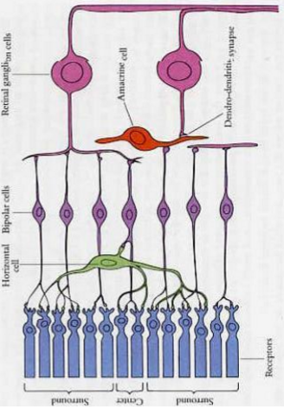

optic nerve sends the signals to the brain.
Optic nerve optic chiasm thalamus (LGN left and right) striate/primary visual cortex (V1)
LGN has 6 layers, the bottom two layers are called magnocellular layers and receive input from M ganglion cells. These are also monochromatic (1,2)
The top four layers are parvocellular layers and they receive input from the P ganglion cells. 4,5,6 and maintain their color
The left eye feeds into the right LGN and vice versa. This is called contralateral.

